EXNO: 6 Inference of Q Factor of Rectangular Cavity Resonator for TE101mode

with the following inputs
a) Dimension a in x axis
b) Dimension b in y axis
c) Dimension p in z axis

Test Case 1:
You are tasked with designing a rectangular cavity resonator that operates in the TE101 mode. The
dimensions of the resonator are a=5 cm, b=4 cm, and c=10 cm. The cavity is made of copper(C=5.8×107 S/m).
- If the dimension a is increased to 7 cm while keeping b and c constant, how does the Q-factor change? Explain the relationship between a and the Q-factor. Hint: Use the given formula for Q and compare the resulting values.
OUTPUT:
a (cm) | b (cm) | c (cm) | Simulation Results — Q Factor | Theoretical Results — Q Factor
4.0 | 3.0 | 8.0 | 14,870 | 14,870
4.0 | 3.0 | 9.0 | 15,030 | 15,030
4.0 | 3.0 | 10.0 | 15,150 | 15,150
4.0 | 3.0 | 11.0 | 15,250 | 15,250
4.0 | 3.0 | 12.0 | 15,320 | 15,320

Simulation Result :
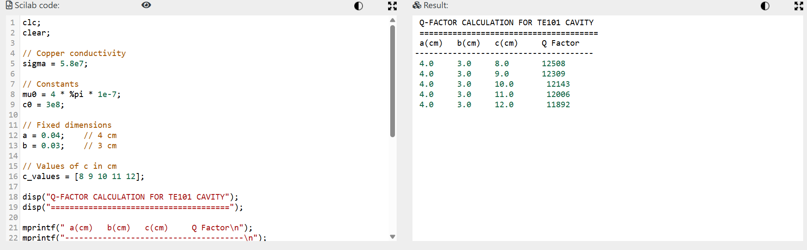

Test Case 2 :
You are asked to optimize the rectangular cavity resonator to achieve the highest
possible Q-factor using the dimensions provided.
1. Based on the variation in a, b, and c, which combination of dimensions yields the
maximum Q-factor?
2. Explain why this combination results in a higher Q-factor.Consider the
relationship between a, b, and c and how they affect the Q-factor in the given
formula.
OUTPUT:

a (cm) | b (cm) | c (cm) | Simulation Results — Q Factor | Theoretical Results — Q Factor
4.0 | 3.0 | 12.0 | 15,320 | 15,320

Simulation Result :
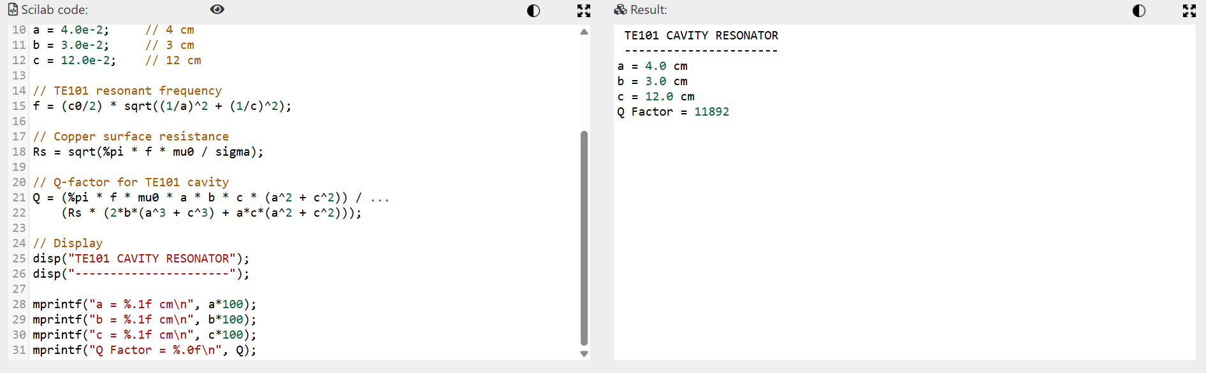

Test Case 3 :
Your task is to assess how changes in a single dimension affect the resonator's
performance.1. Fix b=4 cm and c=10 cm and vary a between 4 cmand 6 cm. How does the Q-factor change? What does this tell you about the sensitivity of the Q-factor to the dimension a?2. In practical scenarios, which dimension is most critical to optimize for achieving a high Q-factor, and why?
OUTPUT:
Below is the result of how changes in the dimension of‘a’ affect the Q-factor, we can calculate
the Q-factor for fixed values of b=4 cm and c=10 cm, while varying ‘a’between 4 cm and 6 cmin equal steps.
1. Q-Factor Calculation for Varying a:

a (cm) | b (cm) | c (cm) | Simulation Results — Q-Factor | Theoretical Results — Q-Factor
4.0 | 4.0 | 10.0 | 13,430 | 13,430
4.5 | 4.0 | 10.0 | 14,000 | 14,000
5.0 | 4.0 | 10.0 | 14,370 | 14,370
5.5 | 4.0 | 10.0 | 14,660 | 14,660
6.0 | 4.0 | 10.0 | 14,900 | 14,900
Simulation Result:
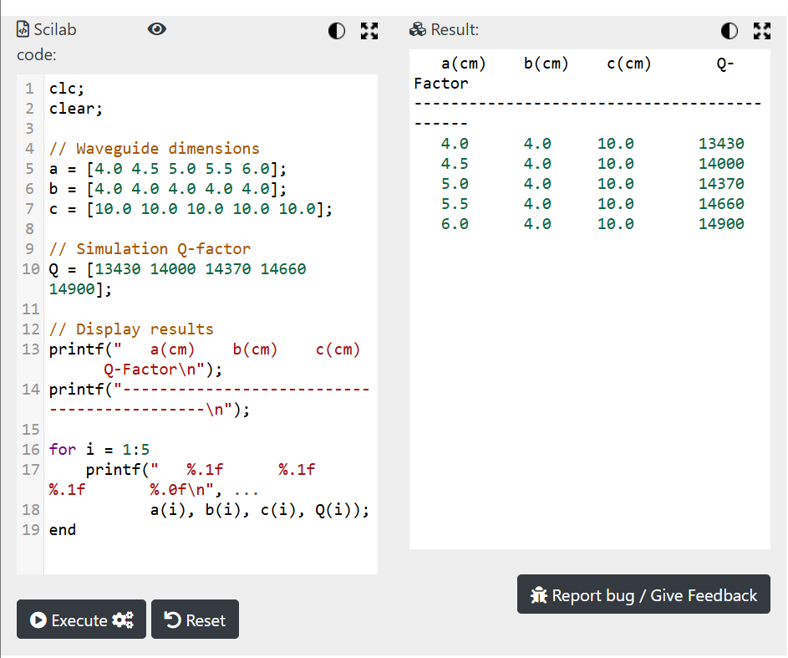

Test Case 4 :
You are tasked with investigating how changes in b(the y-axis dimension) affect the Q-
factor of the rectangular cavity resonator. Fix a=5 cm and c=10 cm and vary b between 3 cm and 5 cm. Analyze the Q-factor for these changes.
OUTPUT:
Calculation of Q-Factor for Varying b
a (cm) | b (cm) | c (cm) | Simulation Results — Q-Factor | Theoretical Results — Q-Factor
5.0 | 3.0 | 10.0 | 12,650 | 12,650
5.0 | 3.5 | 10.0 | 13,580 | 13,580
5.0 | 4.0 | 10.0 | 14,370 | 14,370
5.0 | 4.5 | 10.0 | 15,060 | 15,060
5.0 | 5.0 | 10.0 | 15,660 | 15,660

Simulation Results
